Relational Databases with MySQL Week 4 Coding Assignment

**Points possible:** 70

|  |  |  |
| --- | --- | --- |
| Category | Criteria | % of Grade |
| Functionality | Does the code work? | 25 |
| Organization | Is the code clean and organized? Proper use of white space, syntax, and consistency are utilized. Names and comments are concise and clear. | 25 |
| Creativity | Student solved the problems presented in the assignment using creativity and out of the box thinking. | 25 |
| Completeness | All requirements of the assignment are complete. | 25 |

**Instructions:** Using a text editor of your choice, write the queries that accomplishes the objectives listed below. Take screenshots of the queries and results and paste them in this document where instructed below. Create a new repository on GitHub for this week’s assignments and push this document, with your Java project code, to the repository. Lastly, in the Learning Management System, click the “Add Submission” button and paste the URL to your GitHub repository.

**Coding Steps:**

Write 5 stored procedures for the employees database.

Write a description of what each stored procedure does and how to use it.

Procedures should use constructs you learned about from your research assignment and be more than just queries.

**Screenshots:**

**1 this is used to display all male employees and names**

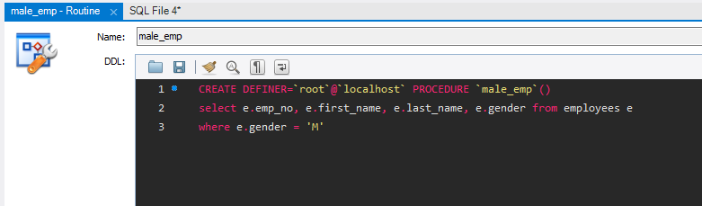

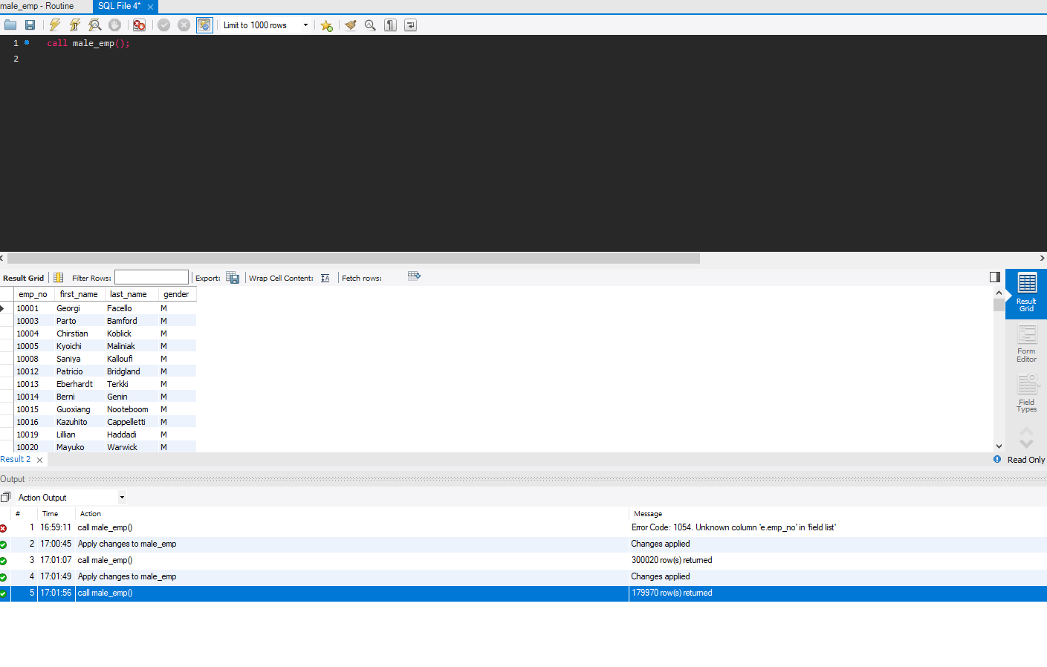

**2 for the second I went further and wrote set procedure where you can pass in male or female for the result for count of employees by gender.**

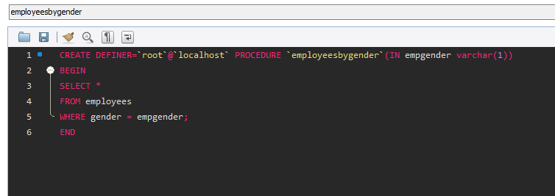

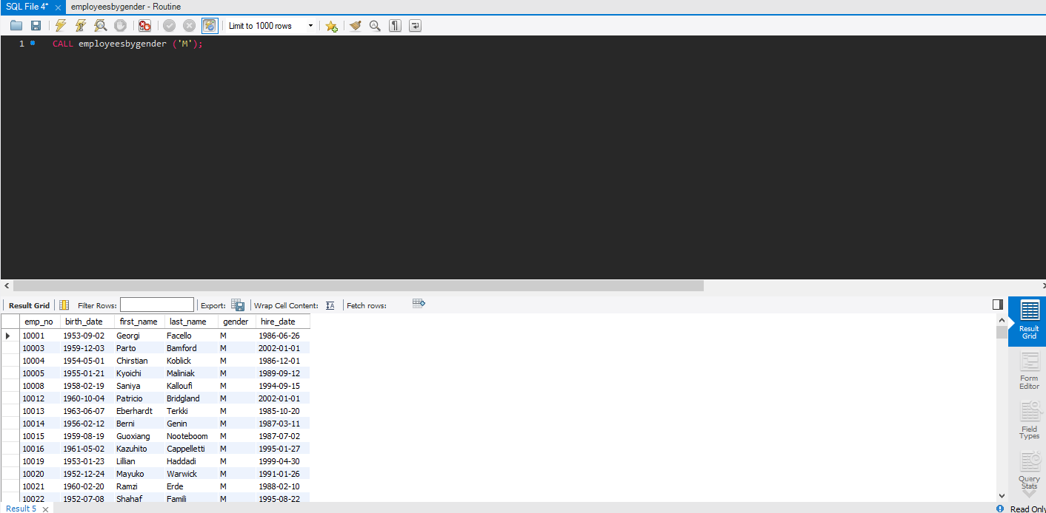



**3 I wrote this to pass the dept name into the procedure and returns the employees and their information for the department specified.**

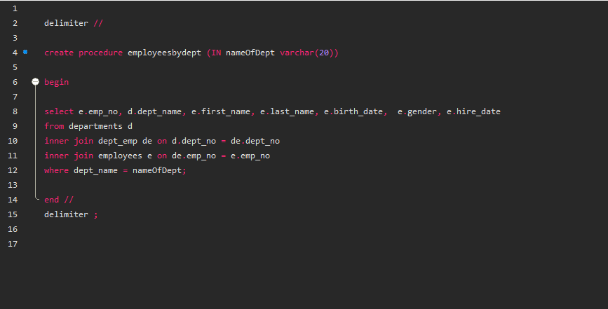

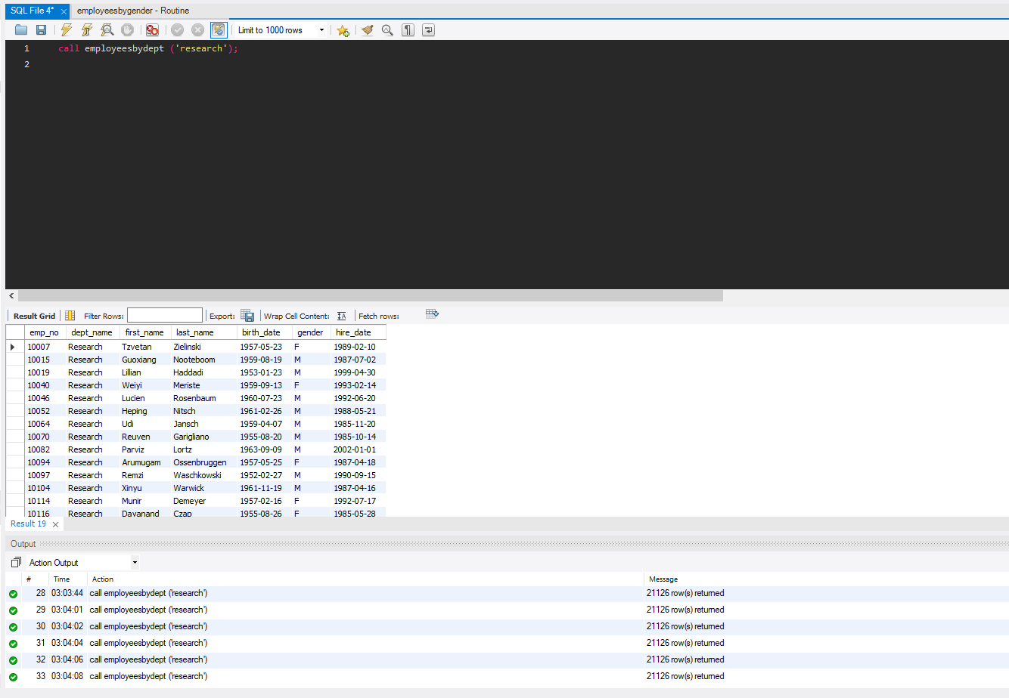

**4 the purpose of this is to provide the total count of employees in the department passed in when calling it**

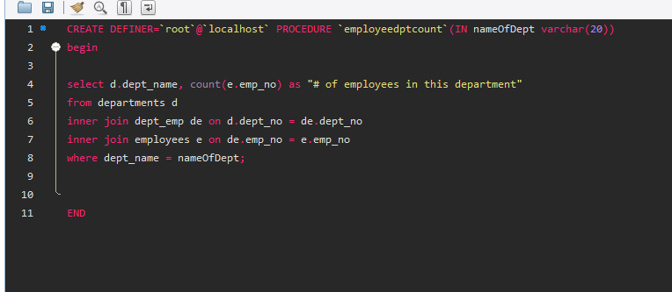

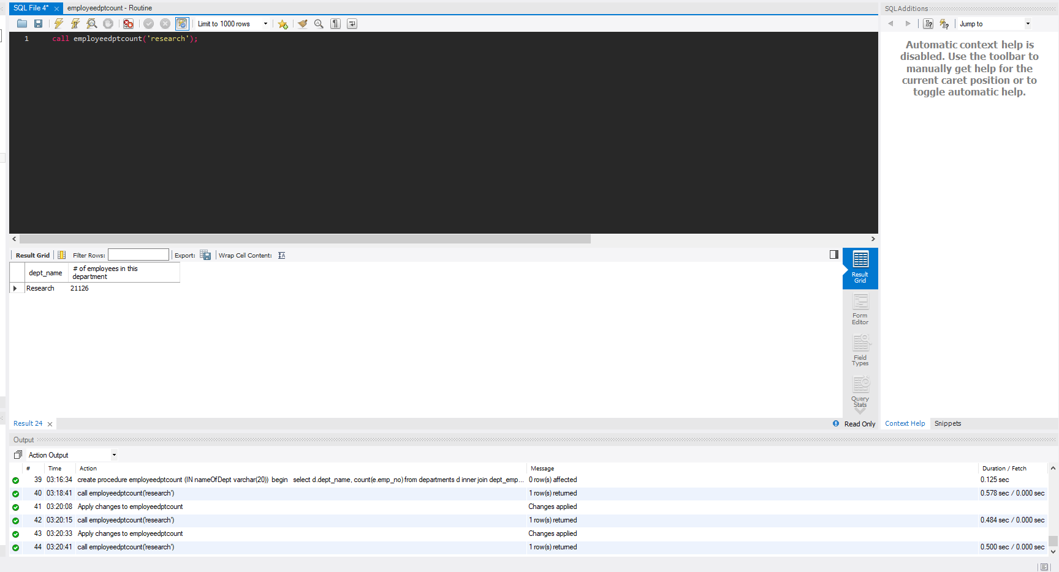

**5 this one is for sum of all salaries by the title put into parameter that returns total spent for all people in that title ie: how much was paid total to senior engineers**

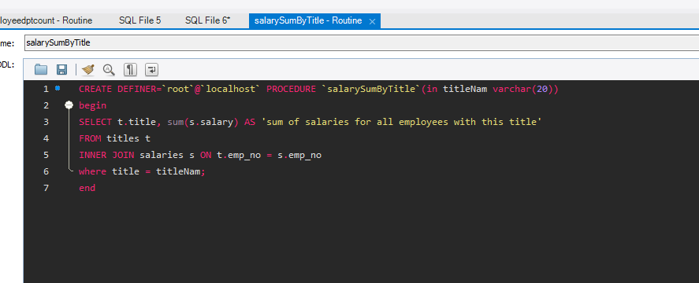

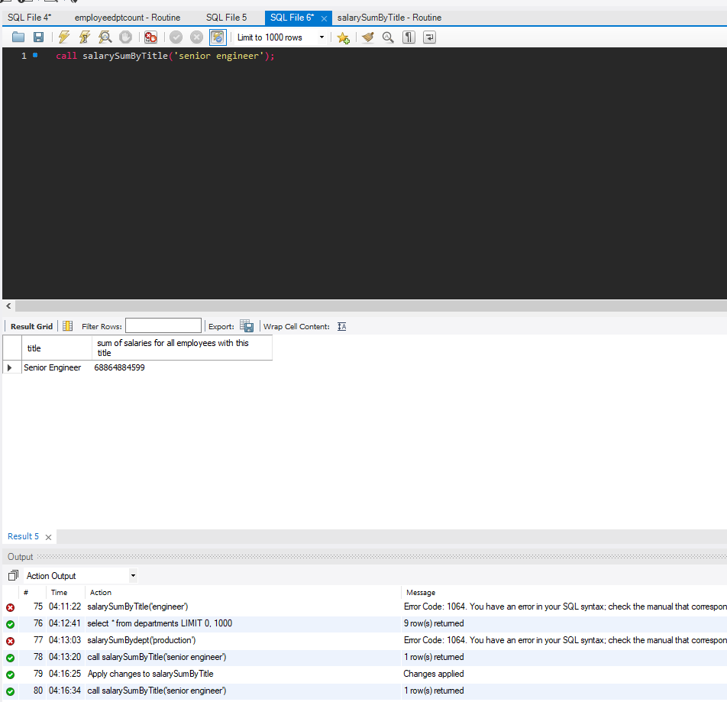

**6 including a 6th one since I couldn’t get it working but went back and found problem this one shows total of salaries by the dept passed into parameter**

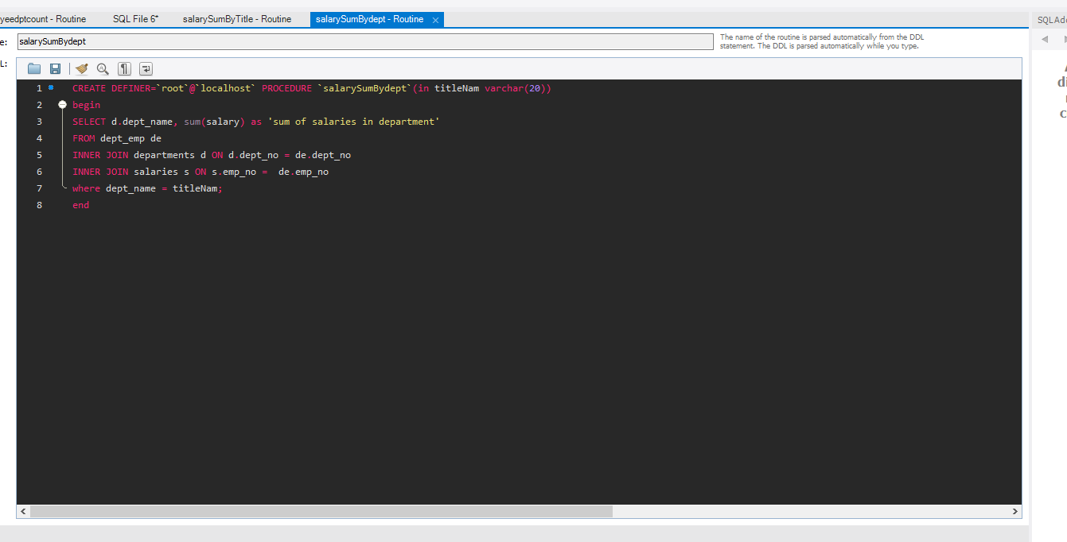

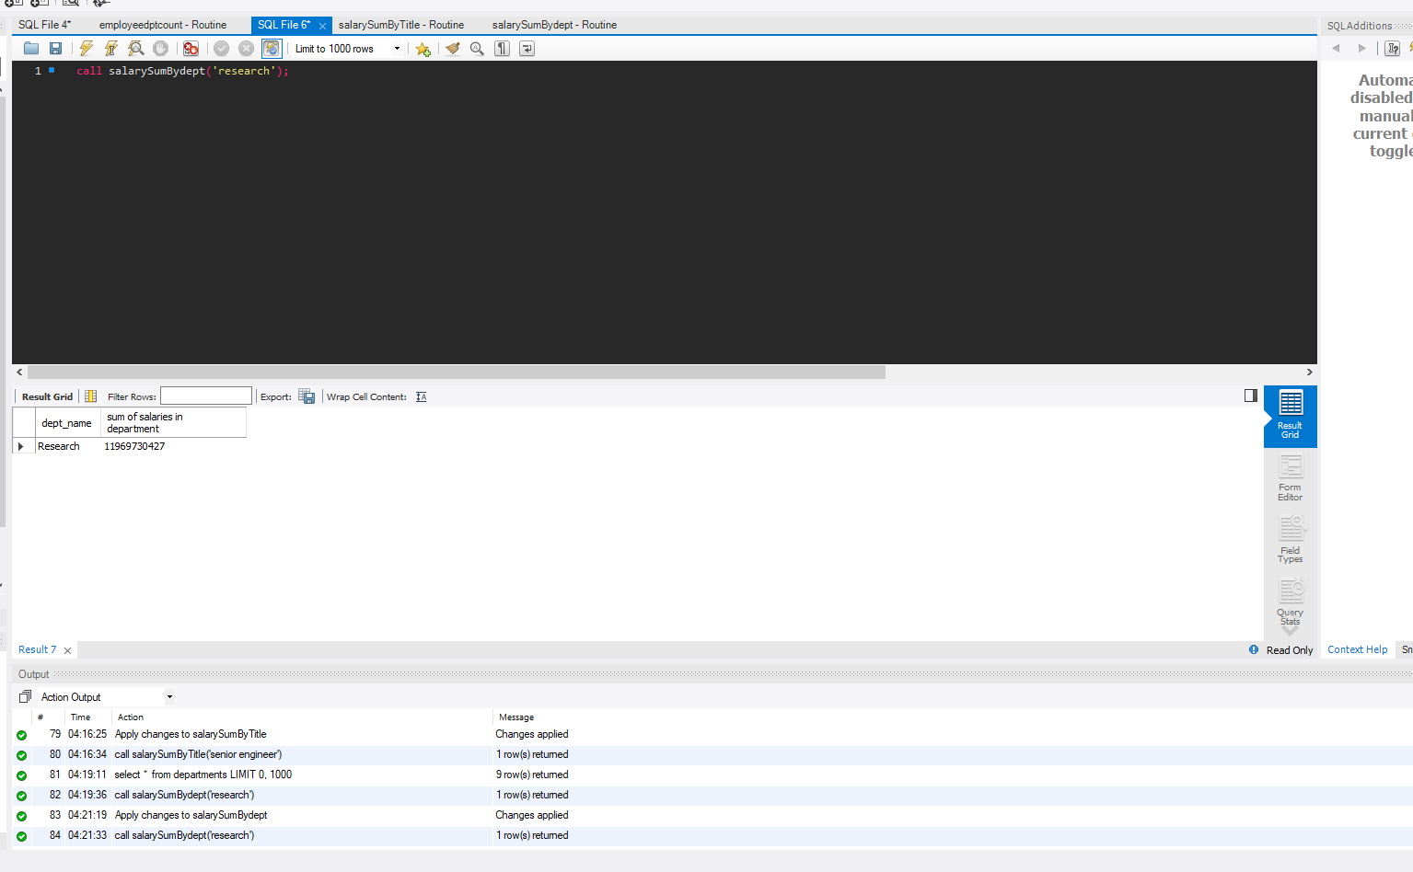

**URL to GitHub Repository:**

**https://github.com/skeletoro/assignments.git**